2022 Long Island Steel Shootout
Match Booklet

Welcome all shooters and staff to the 2022 Long Island Steel Shootout!
Myself, along with all the staff at LIPSA want to start by saying thank you for participating in this amazing match. We have been pleasantly surprised by the tremendous response as well as all the support the club received by our match Sponsors.
PLEASE NOTE: MATCH IS RAIN OR SHINE

This is the official welcome letter along with Match Schedule and Rules.
Match Schedule
Wednesday, July 13th
1000 - 1800 Match Setup
Thursday, July 14th
1000 - 1800 Match Setup
Friday, July 15th
0700AM – Gates Open for parking (Parking in designated parking areas, do not park along road outside gate)
1000 – Morning Registration Opens
1030 – RO Meeting
1145 – Match Briefing and give aways
1200 – First Shots
Saturday, July 16th
0600 – Gates Open for parking (Parking in designated parking areas, do not park along road outside gate)
0600 – 0800 Breakfast will be available on site for purchase

0700 – Morning Registration Opens
0730 – RO Meeting
0745 – Match Briefing and give aways
0800 - Match Begins
1130 - End of morning session/Lunch Break (Lunch available for purchase)
1200 – Afternoon Registration Opens
1230 – RO meeting
1245 – Afternoon Match briefing & give aways
1300 – Afternoon Match begins

Sunday, July 17th
0600 – Gates Open for parking (Parking in designated parking areas, do not park along road outside gate)
0600 – 0800 Breakfast will be available on site for purchase
0700 – Morning Registration Opens
0730 – RO Meeting
0745 – Match Briefing and give aways
0800 - Match Begins

We will be holding to the match schedule so please be on time as we cannot wait for any shooters to begin.

If anyone is available to help with set up please come out on either Wednesday or Thursday, Thank you.

Parking

Competitor Parking – No parking in the front lot. Available parking in the 100 yard range, Sandy pit 1 and 2, steel plate rack pit, training pit and shotgun pit.

LIPSA Staff/RO’s – Please park in the 200 yard range

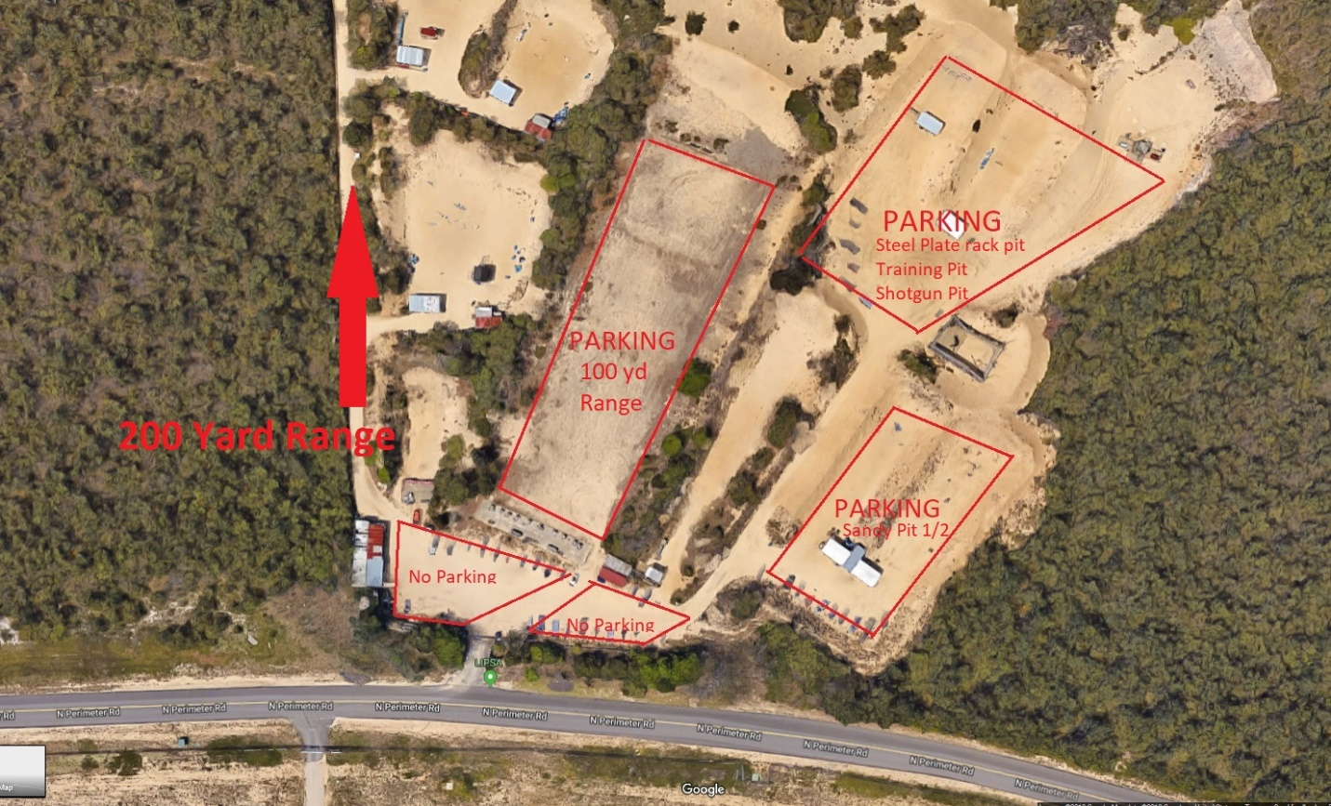

Quick reference for match Rules, please make sure you read the match rules at www.listeelshootout.com
- Eye protection/ear protection must be worn at all times
- LIPSA is a Cold range. Any LE please let LIPSA staff know if you need to unload your firearm when you arrive. Do not walk to the line with a loaded firearm. This will result as an automatic disqualification.
- There is no gun handling in the parking area. If you need to holster a firearm, bring the cased firearm to a safe table and holster your firearm there. Please ask LIPSA staff where the safe tables are located.
- If you don’t have a holster for your firearm then you must leave your firearm cased until you get to the shooters box and the RO tells you to “make ready”.
- All PCC Shooters must have a chamber flag in the firearm. All uncasing and casing must happen with the muzzle pointing toward orange cone/berm. There will be gun rack for you to store your flagged PCC prior to shooting. When moving you PCC to and from the rack you must have the muzzle up.
- Any Magazine that hits the ground once the timer starts is considered a “dead” magazine and cannot be retrieved, if it’s picked up off the ground, it’s an automatic disqualification.
- 60 Second par time per stage, any steel targets left standing will incur a
+ 5 second penalty per target.

Match Squads

www.listeelshootout.com/squads

Trophy Sponsor
www.claudios.com

Match Sponsors
To all shooters, I would like to ask everyone to please reach out to our sponsors who donated tremendously and thank them for their support. The majority of our sponsors are local shops here on long island who stepped up to show their support to the shooters who support them.

www.spguns.com

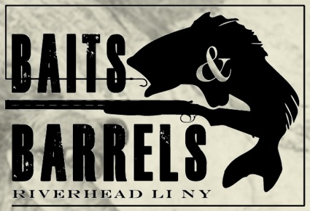
www.baitsnbarrels.com

www.davincimachining.com

www.huntersport.com

www.techwearusa.com

www.huntersessentials.com
https://www.ppdandg.com/

www.ruger.com

http://www.campsitesportshop.com/

http://www.tandemkross.com/

http://www.huntershdgold.com/
http://www.us.glock.com/

http://www.surefire.com/
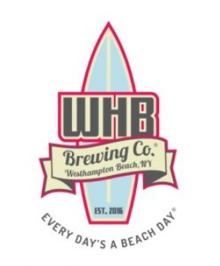
https://westhamptonbeachbrewingco.com/

http://www.techwellusa.com/

www.islercustomgunworks.com/

www.1northsteakhouse.com

https://www.premearhearing.com/
https://www.gtrentals.com/

https://www.gtrentals.com/
https://www.bodyarmorusa.com/

https://www.taconicdistillery.com/
https://www.gofastdontsuck.net/
Stages
